Cell-Gazer - Portable Wide-Illuminating Microscope
Andres Parra, David Ponce, Jacob Roth, Xuan Luo

Department of Electrical and Computer Engineering and The College of Optics and Photonics University of Central Florida, Orlando, Florida, 32816-2450

Abstract — This paper presents a portable microscope project that spans into three engineering fields. Those being electrical engineering, computer engineering, and photonics engineering. The microscope itself can image biological samples around 100μm while illuminating the sample with a variety of different LEDs such as: white, ultraviolet, and infrared. The microscope is portable, lightweight, and battery powered. The microscope also has a companion app to control the stage, change magnification, and control the lighting of the specimen to enhance user experience. The magnification starts at x40 and can switch to x100 with the click of a button.

Index Terms — Batteries, Microscopy, Microcontrollers, Motors, Optical engineering

I. Introduction
Our microscope was designed with the combination of three different engineering fields in mind. We set out to design a high quality microscope which has capabilities that microscopes in our budget range normally do not have such as the ability to image visible, ultraviolet, and infrared light. Our microscope is also paired with a companion app which controls the LEDs as well as the stepper motors, and the imaging of the specimen. To capture images of the specimen, our raspberry pi 4 model B has a no IR camera module. This camera module can image specimens that are illuminated with visible, infrared and ultraviolet light.
The app controls the motors by sending a SPI signal from a mobile device over WiFi, then passing that SPI signal to the ATMEGA 2560 microcontroller which then passes the signal to the ULN2003 motor drivers. One stepper motor moves the microscope’s stage up and down in a vertical fashion to control the focus of the specimen. The other stepper motor controls our magnification by swapping from one objective lens to the other. One objective lens has a x40 magnification while the other has a x100 magnification. The image captured by the Raspberry Pi Camera Module V2 will be sent back to the app via WiFi for image processing and image storage. The app contains various image processing techniques.

II. Overview of the cell-gazer design
Our portable microscope is a compact, affordable and highly-capable microscope that can be used for a variety of imaging applications. The dimensions of the microscope are: 13.25” x 10” x 21.5”, and weighs less than 9 lbs making our microscope portable. We have also designed our microscope with sustainability in mind, so in order to power the electrical components we have implemented rechargeable batteries. Two rechargeable batteries are connected to our Raspberry Pi 4 and two more batteries are connected to our main PCB. The main PCB houses the ATMEGA2560 microcontroller, the CH340C micro-usb driver, and the digital and analog pins. For our electrical components to have the desired voltage, we also implemented voltage regulators to keep our system at a low 5V.
Our design also includes four different kinds of LEDs that have a wavelength range from white light at a range of 450 - 700 nm, ultraviolet light at 390 - 395 nm, and two infrared wavelengths, one at 850 nm and another at 940nm. All types of these LEDs are solder mounted onto a compact PCB built specifically for this project. Overall we have three PCB designs, the MCU, the voltage regulators, and the LED PCB. Our engineering specifications which summarize the technical needs of our project can be seen in Table 1 below. Our engineering specifications range from latency of the motors, the angle of which the turntable can turn, and the wavelength of the white LEDs. The three key engineering specifications are highlighted in orange.

Table 1 - Engineering Specifications
Component | Parameter | Specification | Unit(s)
Objective Lens Motor | Latency | 2 | seconds
Turntable for objective lens | Turn Radius | 360 | degrees
White LED | Wavelength | 450-700 | nm

III. Microscope Design
A portable microscope made by a previous Senior Design group in 2018 inspired us to improve our microscope.
Their microscope has white and IR LED light source, two objective lenses, and an image sensor. This microscope is able to resolve samples approximately around 150 µm. There are two different levels of magnification—4x and 10x.
We will improve the constraints in their design and make a better microscope. They only used visible and IR rays as the light source, so we would like to make a microscope that has a wider spectrum than theirs. We would like to use several magnifications above 10x in our project as well.
Our desired microscope is a compound wide-spectrum illuminating 2-in-1 bright field and dark field microscope. It consists of a light source, a condenser lens, a diffusion filter, two objective lenses, one neutral density filter, one tubular lens, and an image sensor. Our basic goal is to resolve around 100 𝜇m, our advanced goal is to resolve around 80 𝜇m, and our stretch goal is to resolve around 20 𝜇m. In this section, we will go over each selection for major optical components and our essential designs.
- Achromatic Objective Lenses
There are generally two kinds of objective lenses that are available on the market. One is corrected for infinite long and the other one is corrected for 160 mm. The one for 160 mm can give a variety of magnification levels with a combination of tubular lens, so we chose this kind of objective lens for our project.
We picked 40x and 100x objective lenses corrected for 160 mm. The focal length of the 40x objective lens is $160/40= 4 mm$. The focal length of the 100x objective lens is $160/100 = 1.6 mm$. These two focal lengths enable us to have enough room in front of the objective lens to place our samples. Everytime we switch the objective lens for use, the position of the sample needs to be adjusted to refocus.
The objective lenses we picked are achromatic, and they are corrected for red, green, and blue. Those objective lenses are available on Amazon, and they fit common size (DIN/JIS standard) with 20 mm mounting thread in diameter. The aperture of the 100x objective lens is 1.25 and it is 0.65 for the 40x objective lens. Both objectives are made for imaging samples with a thickness of 0.17 mm of the glass cover slip for best performance.
B. Tubular Lens
Technically speaking, we only need one objective lens to image. However, the magnification will change as the position of the sample changes for focusing. Therefore, we chose to use one tubular lens to fix the magnification for the entire microscope.
The resolution is Δ$r$ = $λ/2NA$ = 390 nm/(2x0.65) = 300 nm. We picked UV light to calculate the resolution because it gives the highest resolution. The pixel size of our image sensor is 1.12 𝜇m (see image sensor section), and for optimal sampling, $Δr$ > 5 pixels is required. Hence, $Δr$/5 = 300 nm/5 = 60 nm. The magnification for the entire microscope should be 1.12 𝜇m/60 nm = 18.67x. The magnification equals the focal length of the tubular lens divided by the focal length of the objective lens. Therefore, the focal length of the tubular lens should be 18.67x 4 mm = 74.68 mm ~ 75 mm.
We borrowed our tubular lens from the CREOL undergraduate lab. It is a Thorlabs bi-convex lens with an effective focal length of 75 mm, and its diameter is 25.4 mm. It is applicable for a wavelength range from 350 nm to 2 𝜇m. Our light source wavelength range is from 390 nm to 940 nm, so this tubular lens will not absorb our illuminating light.
C. LED light source and Design
The other senior design group used white and 850 nm IR LEDs as their light source. We would like to improve it by using three kinds of LEDs — UV, white, and IR. UV light enables a higher resolution, white light provides enough brightness, and IR light enables live specimen imaging.
We have chosen white, 850 nm IR, 940 nm IR, and 395 nm UV LEDs. We made this decision because these LEDs can provide stable light in three different spectra.
The most common diameter we can find for UV and IR LEDs is 5 mm, thus making us have to choose 5 mm as our LED light bulb size. Therefore, the LED layout will have three small circles of LEDs, and the actual diameter of the illuminating circle is $6d$. The actual illuminating area will be $π(3d)^{2}= 9$$πd^{2}= 225π$, and the area of the biggest lens in the system is $πr^{2}= 161.29π$. The LED illuminating area can totally cover all the lenses in the imaging system.
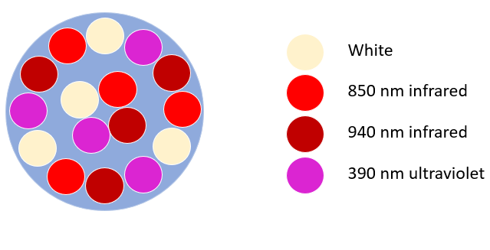
Fig. 1. LED Layout Design
All the LEDs should be placed symmetrically in order to be equally distributed when illuminating samples. As shown in Fig. 1, we chose a single symmetrical pattern of four LEDs of one kind, and then just simply rotated this pattern for the other three kinds of LED. We ended up with 16 equally distributed LEDs.
D. Image Sensor
We chose our image sensor based on the resolution required by our stretch goal. Our stretch goal is to resolve 20 𝜇m, and we would like to pick a diffraction-limited image sensor for our project accordingly.
The formula for diffraction blur is $2.44Fλ$, where F is F-number and $λ$ is wavelength. When the ratio of $Fλ$ to $d$ (pixel size of image sensor) is equal to 2, optimal sampling in an imaging system is adopted. Then if we substitute $Fλ= 2d$ to the diffraction blur formula, we have 2.44 x 2d = 4.88d. Since our stretch goal is to resolute 20 𝜇m, the diffraction blur needs to be set as 20 𝜇m. Therefore, we have 4.88d = 20 𝜇m, d = 4.1 𝜇m. It means if the pixel size of the image sensor is equal to or smaller than 4.1 𝜇m, the image sensor can achieve a diffraction-limited performance in our imaging system.
We looked through all the image sensors provided by Raspberry Pi and we picked Camera Module v2 to be our image sensor. Its pixel size is 1.12 𝜇m, so that it ensures a diffraction-limited performance. Its working wavelength is from 350 nm to 1100 nm, so it ensures that it is capable of capturing UV, white, and IR light rays generated by our light source.
E. Two-Lens Imaging system
We will use one objective lens and one tubular lens to magnify biological samples and focus the image into our image sensor. Technically speaking, only using one objective lens can totally achieve what we attempt to do; however, everytime the sample position changes, the magnification of the entire imaging system will change correspondingly. In bio-imaging systems, it is common to add an extra lens, called tubular lens, to avoid the change of magnification. With a tubular lens, we can fix the overall magnification of our system, no matter how we adjust our sample position. This is why we chose to build an objective-tubular (two-lens) system for imaging.
The tubular lens will be placed 160 mm after the objective lens because our objective lenses are corrected for a tube length of 160 mm. As stated in the Tubular Lens section, our tubular lens is a Thorlabs 25.4 mm BK-7 imaging lens with a focal length of 75 mm. We entered the parameters of this tubular lens in Zemax and simulated the performance of this tubular lens with parallel incoming light rays. The wavelengths are set to be white (486 nm, 587 nm, and 656 nm), UV (390 nm), and IR (850 nm and 940 nm). With the field editor, we used four fields in total, which are 0, 0.5, 1.0, and 1.5 degrees in the object plane. This procedure helps us to estimate the aberrations occurring within the full field.
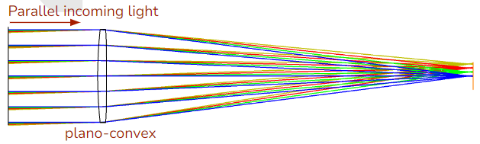
Fig. 2. Tubular Lens Focusing light rays in Four Fields
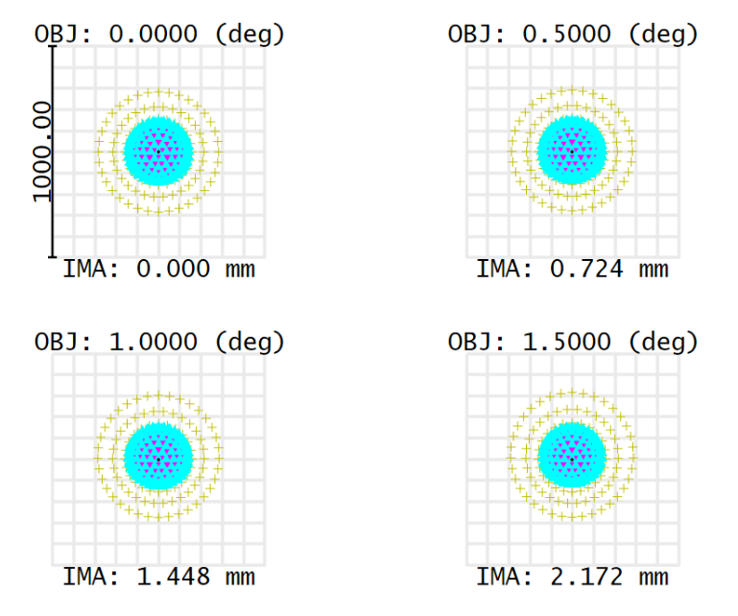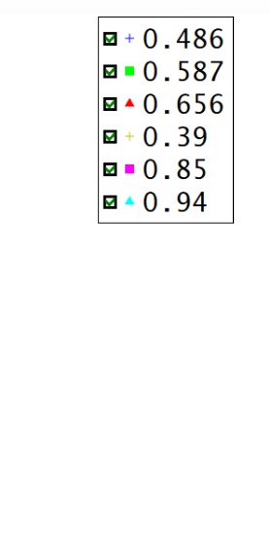
Fig. 3. Spot Diagram generated by the Tubular Lens

In Fig. 3, it is clear that the light rays at different wavelengths do not “merge” into one perfect spot. This brings chromatic aberration to the resulting image. Therefore, we will need to filter out one certain wavelength for imaging. It is also obvious that all the light rays form an exactly same pattern in four different fields. This means that the tubular lens we chose introduces very small distortion to the resulting image.
1. Resolution
The resolution in the image plane is determined by the wavelength of the illuminating light and the numerical aperture of the objective lens, which can be calculated by $Δr=λ/2NA.$ Since our illuminating spectrum is from 390 nm to 940 nm, the resolution is going to change when different wavelengths are used. When UV light is used, the resolution is 300 nm, which is the highest resolution
among all the wavelengths; when 940 nm IR light is used, the resolution reaches the lowest, which is 723 nm.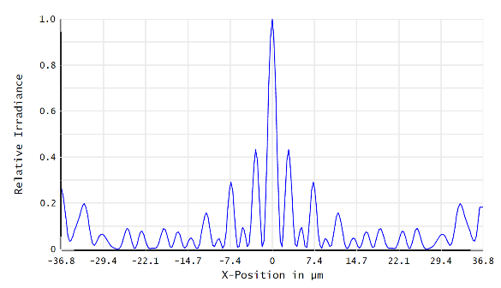
Fig. 4. Point Spread Function of the entire imaging system at all wavelengths

We extracted out the point spread function of our two-lens imaging system and it indicates that our imaging
system has a diffraction limit around 0.5 𝜇m at all wavelengths (Fig. 4). This number is relatively close to the resolution limits obtained by wavelength and having a diffraction limit at 0.5 𝜇m is more than enough to resolve around 20 𝜇m (our stretch goal).

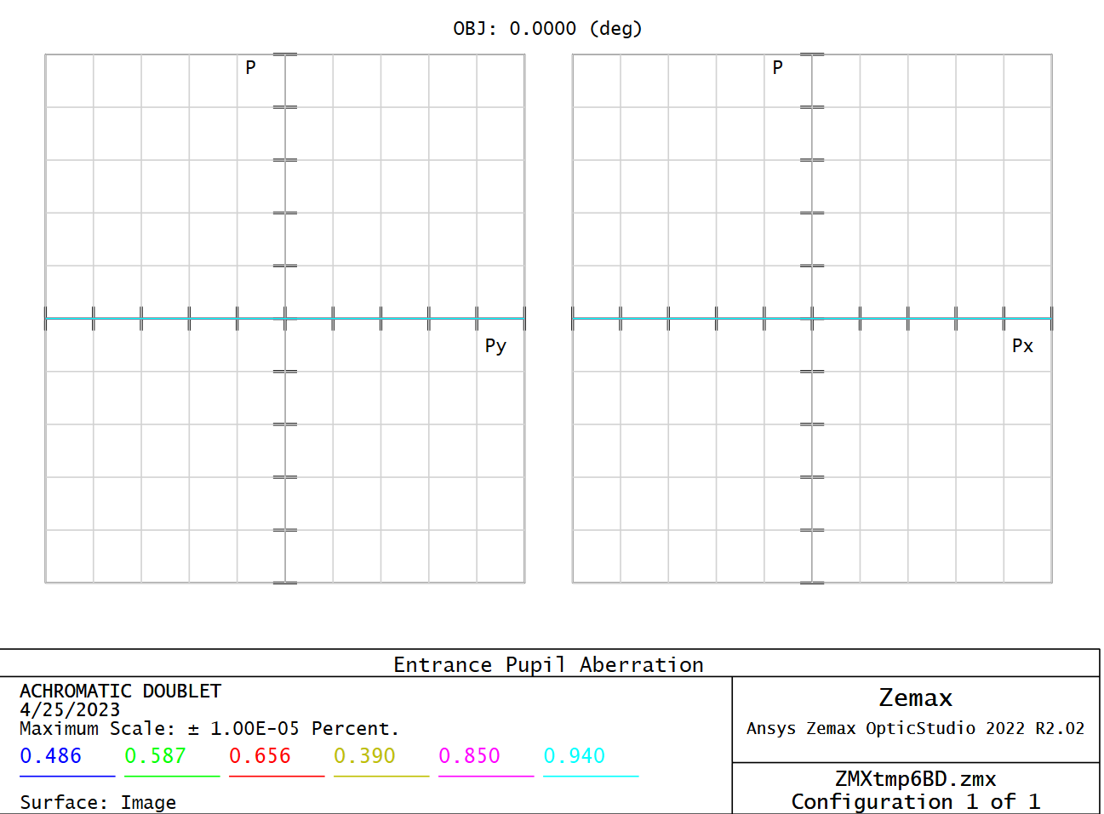
Fig. 5. Pupil Aberration

We extracted the information about the pupil aberration occurring in the system and kept modifying the parameters until we obtained minimal aberration at all wavelengths. As shown in Fig. 5, the pupil aberration remains zero along the x-axis and the y-axis. This result is fascinating.
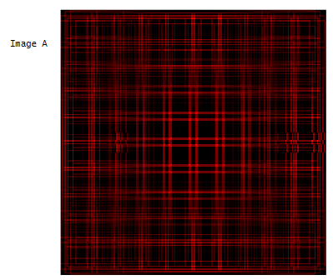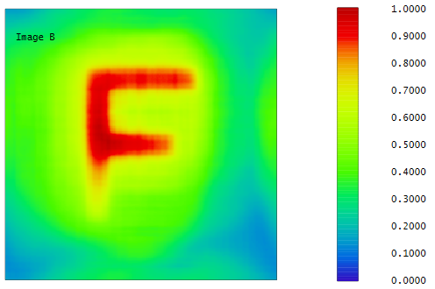
Fig. 6. Image Simulation. A is a simulation of a grid of lines with a size of 0.001 mm (W) x 0.001 mm (H). B is an extended diffraction image simulation of letter ‘F’.
We ran two image simulations to test the overall image quality. image A is the simulation of a grid of lines that is 0.001 mm both horizontally and vertically. The center of the image is clear with high contrast, minimal aberrations, and minimal distortion. The central area is satisfactory but the image around the edge experiences more aberration and distortion. Therefore, when we use the microscope, it is better if we image our samples at the center of the lenses. Image B is a diffraction image obtained by simulating the performance of our imaging system with a letter ‘F’. This also shows the central part of the sample gets a better imaging result by the system.
2. Magnification
The 40x objective lens has a focal length of 4 mm. With our tubular lens with a focal length of 75 mm, we can obtain the overall magnification of the entire imaging system by calculating 75 mm/4 mm = 18.5x, so our microscope has a fixed magnification of 18.5x with the 40x objective lens.
The 100x objective lens has a focal length of 1.6 mm. With the same tubular lens, we can obtain the overall magnification as 75 mm/1.6 mm = 46.875x ~ 47x. Therefore, our microscope has a fixed magnification around 47x with the 100x objective lens.
3. Field of View
The pixel size of our image sensor is 1.12 µm x 1.12 µm, so using 40x objective lens, in the sample plane, one pixel is $1.12 μm/18.5=60.5 nm$. The sensor has 3280(H) × 2464(V) pixels. Hence, the horizontal field of view is $3280x60.5 nm=198$$μm$ in the sample plane; the vertical field of view is $2464x60.5 nm=149$$μm$ in the sample plane.
For 100x objective lens, one pixel is $1.12 μm/47=24 nm$. Thus, the horizontal field of view is $3280x24 nm=79$$μm$ in the sample plane; the vertical field of view is $2464x24 nm=59$$μm$ in the sample plane.
F. Illumination system
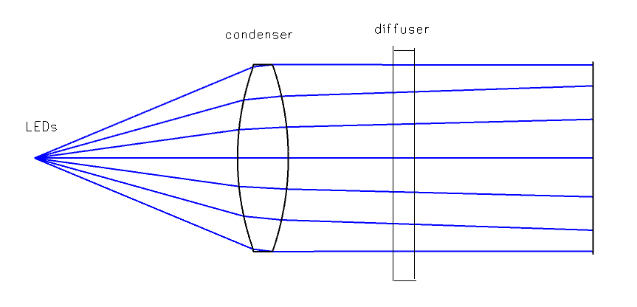
Fig. 7. Lambertian diffuser illumination system
This illumination system consists of one lens and one diffusion filter (Fig. 7). The condenser will first convert the original light beams into parallel beams, and then the diffusion filter will scatter and ‘mix’ all the light beams. Thus, the original light source can be turned into a uniform light source. This system has less lens than typical Köhler illumination system and is easier to implement.
G. Bright mode and Dark mode
In order to make our microscope more competitive, we would like to have two different modes for our microscope – bright mode and dark mode.
The bright mode stands for bright-field microscopy. When bright mode is on, both the central and the outer circles of LEDs will be turned on. The LED light beams will first illuminate the sample and then get captured by the objective lens for imaging.
The dark mode stands for dark-field microscopy. When dark mode is on, the central circle of LEDs will be turned off and only two LEDs on the outer circle will be turned on. The two LED light beams will illuminate the sample, but they will not be captured by the objective lens as they both propagate at an angle that is bigger than the maximum acceptable angle of the objective lens. The objective lens, thus, only captures the light that is scattered by the sample. In general, dark-field microscopy gives a better contrast than bright-field microscopy.
The switch between the bright mode and the dark mode will be done by controlling which LED gets turned on on the PCB and the position of the LED PCB. A detailed explanation of how we achieve controlling LEDs will be given in the PCB design section.

IV. Hardware
The hardware present on our microscope is solely dependent on our project’s needs. Firstly we must take a look at the basic functionalities of a microscope such as providing a large enough magnification that one could view microscopic specimens, as well as the ability to move and adjust the specimen into focus, and the ability to switch between objective lenses that provide different amounts of magnification. Additionally, we will be implementing other functionalities like livestreaming the microscope’s view over a web application and mobile app, as well as enabling the ability to remotely operate the microscope and take pictures of a specimen that can later be edited and processed within the application.
A. Development Board
In the early stages of our project we chose to use a development board, allowing us to use a predefined
infrastructure to test various designs and implement functionalities. For this purpose we chose the Raspberry Pi 4 B, which uses a Broadcom BCM2711 quad-core 64 bit microcontroller clocked at 1.8GHz. This was our best option as the microcontroller on the Raspberry Pi greatly outperformed the ones on our other options, and was the best suited for the more computation heavy operations of our microscope such as image processing and network communications.
The Broadcom BCM2711 also had the greatest memory and storage out of our other options, which once again was best suited for our needs as a greater memory allows for faster performance on complex tasks requiring millions of instructions, and a large storage was perfectly suited for storing and transmitting pictures and live video. Additionally, the Raspberry Pi was also the only development board with an on board wifi chip, allowing us to develop the network functionalities of our microscope alongside the software portion.
B. Microcontroller PCB
With the intense computational load being put on the Raspberry Pi, we sought to use an additional microcontroller to control some of the microscope’s basic features such as adjusting the specimen, switching objective lenses, and illuminating the specimen. For this purpose we chose the AtMega2560 8 bit microcontroller. This chip was an ideal candidate to control the microscope’s basic functionalities because of the low power consumption and the amount of I/O pins for us to use. In order to enable communication between the AtMega2560 and the Raspberry Pi, we designed and printed a PCB that includes a microUSB port that can be used to connect to one of the Raspberry Pi’s USB ports. 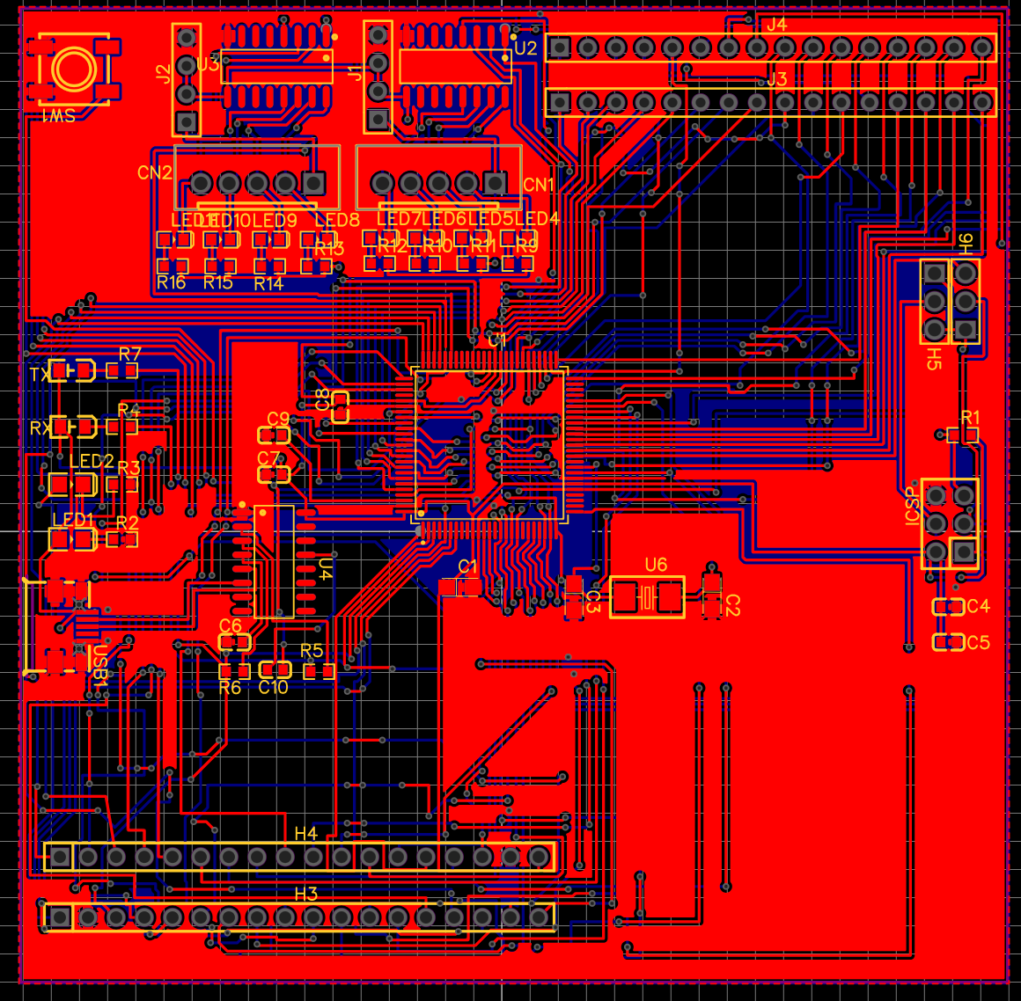
Fig. 8. Layout of the main PCB containing the ATMEGA2560 MCU. Made in EasyEDA.

This connection allowed us to send commands from the Raspberry Pi to the Atmega2560 through SPI. Aside from the various I/O pins, we also included the ICSP pins on the PCB in order to easily program the microcontroller after it has been soldered on the board.
C. LED PCB
One of the major features of our microscope is that specimens can be illuminated with various kinds of light. For this purpose, we have designed a separate PCB with LEDs of various kinds. The types of light included on our LED PCB are: white light, ultraviolet light, infrared at an 850nm wavelength, and infrared at a 950 nm wavelength. The layout of the LED PCB can be seen below in Figure 9.
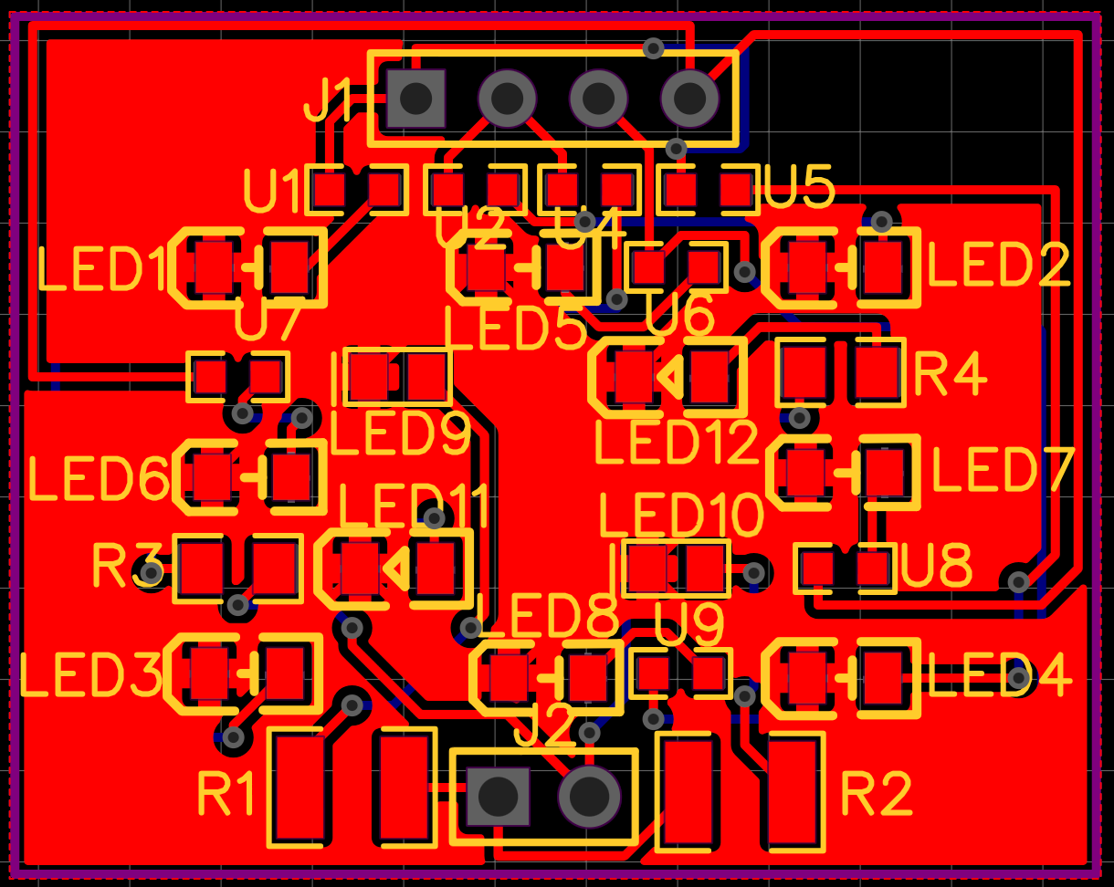
Fig. 9. Layout of the LEDs on a PCB. Designed with EasyEDA.

D. Voltage Regulator
Our system was designed to run at 5V via battery power. To power both the Raspberry Pi 4 and the main PCB, we used two voltage regulators to take in 7.4V and step the voltage down to 5V. This was done to prevent any damage to our boards. The voltage regulators were designed with the help of TI WEBENCH power designer. The voltage regulator was built in EasyEDA.
E. 3D printed parts and design
Most of the pieces and mechanisms of the microscope have been fitted together with specially designed 3D printed parts. The optical train of the microscope relies on a rail system that ensures that the lenses are all aligned. We designed three rectangular sections of tubing that fit with the rails in order to ensure that the lenses are all aligned, as well as a very precise distance from one another. At the lower end of the optical train, the final piece of tubing includes a slot to hold a stepper motor that will sustain and rotate the 3D printed turntable, which will in turn hold the objective lenses. The turntable is also carefully designed so that the objective lenses are aligned with the rest of the optical train, and needs no adjustment beyond the digital input from the web app.
Additionally there is a specially designed piece that holds the Raspberry Pi’s camera while ensuring that the camera is perfectly centered and can clearly see the specimen being magnified. These pieces make up the main body of the microscope. On the backside of the microscope’s mount, there are some additional boxes that have been 3D printed to fit the various PCBs and hide some of the microscope’s electronics.
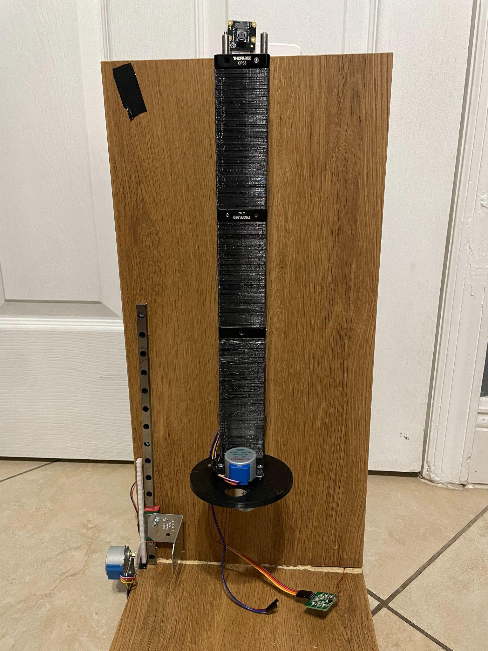
Fig. 10. 3D printed microscope body assembled with the stage and turntable on wooden platform
F. Stepper Motors
We have implemented two stepper motors to automate the controls of the basic functions of our microscope. One stepper motor controls the stage of the microscope and the other motor controls the turntable. The stepper motors will be passed SPI signals through an external motor driver called the ULN2003.
G. Vertical Stage Control
For our microscope stage, we chose to use plexiglass as it is a clear material for the specimen to be placed on and the LEDs can shine through. Plexiglass is also lightweight and easy to work with. To control the stage we have connected the stage to a linear rail guide using metal L-pieces. The linear rail also has a linear gear attached to it for the stepper motor gear to control. When these gears are combined, the stepper motor will be passed an SPI signal to either move the stage up or down. As the stage moves closer to the objective lens, the specimen comes into focus.
H. Turntable
To control the magnification of the microscope, we have used two objective lenses. One at x40 and the other at x100. We implemented a 3D printed component we named the “turntable” which houses the two objective lenses and spins in a circular fashion in order to swap from one objective lens to the other. This provides the user with quick and easy switching between magnifications, giving flexibility and convenience during observations. The microscope’s turntable is designed to have multiple lenses and can be easily operated through our app.

V. Software
We have various pieces of software integrated into the Cell-gazer, from Web app, and Mobile app development that being front end, and backend development to embedded system design in that Printed Circuit Board and server side development in the Raspberry Pi.
- The App
The app has various functionalities, a typical use for the app as user will entail a log in, register prompts allowing the user to make and account or log into their account if one is already created, once the user is logged in, the user will see a real time video display of the specimen under the microscope. The user will be able to use buttons on the app to control the motors mounted on the microscope that control the amount of magnification and the distance between the focusing lens and the sample. There will also be a set of buttons to control LEDs- being able to control the four different types of LEDs, Two types of Infrared, one Ultra violet and white light. Once the user has configured the settings that suit the sample, The user can click a button and take a photo, once this photo is taken the user can then edit the photo, sharpening, blurring it or cropping it out. Either the user can continue editing the photo or not, now the user can save the photo to the database, or local storage, that being the phone or the PC. How the systems work and are integrated with each other can be seen in Fig. 1.
B. Registering/Logging
The login and registering functionality work in that the user inputs their data and the api checks the database using express api to see if the fields exists in the mongodb database, if they exists and the user is attempting to log in the login is successful, if the are trying to register then it does not work and lets them know the username is already taken this login and registering inputs can be scene in figure 2.
C. Real-time video display
The way the application is getting a real time display is through the raspberry pi. The raspberry pi gets the internet through WI-FI. The raspberry pi uses OpenCV libraries via python code to get a live feed from the camera module, once that live feed is attained the python code launches a flask server where everything is displayed in an html website. Once that website is running on the flask server, The app uses a webview package in react to get that html website from the flask server and display it on the mobile app.
D. Controlling the microscope
The Application archives control the microscope through the same python code that launches the flask server. There is various post functions on the html that lets us pass keywords to the python code that let the Raspberry Pi know what SPI bits to send to activate what, for example if the user wants to turn on all the White lights the keyword would be “WHITE/n”. So the button press that is labeled white would send a post with the keyword to the python code which will send that keyword to the Printed circuit board via SPI. This is the same if the user wanted to control the Magnification of the stage where the sample is.
E. Embedded system
The Printed Circuit board embedded system works by controlling a system that consists of LEDs, a turntable motor, and a stage motor. The code is written in C++ and uses Arduino’s serial communications library to send and receive signals from the Raspberry Pi. This is done in a never ending loop that continually checks for a serial signal. The main PCB receives a command in the form of a string that triggers an action on the microscope. For example, if the command is "White_LOW", it sets the White LED pin to HIGH and other LED pins to LOW. Similarly, there are commands to control the state of other LEDs (White_HIGH, IR_HIGH, IR_LOW, IR2_HIGH, IR2_LOW, UV_HIGH, UV_LOW, LEDOFF). These commands control the lighting conditions of the system.
There are also commands to change the objective lens position. If the command is "OBJ40", it rotates the turntable motor to position the objective lens to 40. Similarly, if the command is "OBJ100", it rotates the turntable motor to position the objective lens to 100.
The commands "STGUP" and "STGDOWN" control the movement of the stage motor. If "STGUP" is received and the level is below 15, it moves the stage motor up by incrementing the poleStep2 variable. If "STGDOWN" is received, it moves the stage motor down by decrementing the poleStep2 variable.
F. Capturing images
The Application captures an image using the library called webview the way this works is that once the function is passed the app takes a screenshot of the designated area, this is then saved as a tokenized file inside the own application as a jpeg which can then be passed to different parts of the app.
G. Photo Editing
The application incorporates the OpenCV library to provide a range of photo editing functionalities such as sharpening, blurring, cropping, and zooming. OpenCV is a powerful computer vision and image processing library that offers extensive capabilities for manipulating images and videos. By leveraging OpenCV's algorithms and functions, the application can enhance the visual quality of photos and make various adjustments to meet the user's editing requirements. One of the key features available is sharpening, which enhances the clarity and detail of an image by emphasizing the edges and fine details. This can be particularly useful for improving the overall sharpness and definition of images that may have appeared slightly blurred or soft. Conversely, the blurring function allows for the intentional reduction of sharpness and the creation of a smoother and more diffused effect. This technique can be applied to achieve various creative effects or to diminish noise and imperfections in an image.
Additionally, the application enables users to crop and resize photos, allowing them to focus on specific areas of interest or adjust the composition of the image. Cropping can help remove unwanted elements or distractions from the frame, while resizing allows for scaling the image to fit specific dimensions or aspect ratios. Furthermore, the zooming functionality allows users to magnify specific portions of an image, providing a closer look at details that may not be easily discernible in the original image. This feature can be particularly useful for examining fine details or for emphasizing specific areas of interest within a photo.
H. Database/Storage
The application also includes features for user authentication and data storage. When a user registers or logs in, their credentials, including username, email, and password, are securely stored in a database. This ensures that user information is protected and allows for easy retrieval and authentication during subsequent login attempts.The application utilizes Express.js, a web application framework for Node.js, to handle the server-side functionality. With the help of Express.js, the application implements the necessary routes and endpoints to handle user registration, login, and data storage. When a user registers or submits their credentials, the application employs the POST method to securely transmit the data to the server. The server then processes the data and stores it in the database, ensuring the information remains persistent and accessible for future authentication.
Similarly, the application employs the GET method to retrieve stored user data from the database. This allows for seamless user authentication during login attempts, as the application can compare the provided credentials with the stored data to verify the user's identity. While the application effectively stores user credentials and related information in the database, it currently only provides local storage for the photos. This means that the edited photos are stored locally on the user's device rather than being uploaded to a remote server or cloud storage. Local storage offers convenience and allows users to access their edited photos directly from their device.

VI. Previous Projects
The previous group that had designed a portable microscope was Fall/Spring group 27’s Portable microscope [1]. We thought that this project was a perfect fit for our group because we have a diverse team of engineers ranging from photonics engineering, electrical engineering and computer engineering.
VII. Conclusion
We tested our microscope with multiple specimens enclosed by biological-use slides and 0.17 mm coverslips. As shown in Fig. 11, white LED is good for imaging colorful specimens; UV LED can increase the resolution; IR LED is good for imaging the structure of specimens.
The intensity-distance plots are extracted for selected resolved distances under bright-mode and dark-mode (Fig. 12). The resolution under bright-mode is thus 1.03 𝜇m - 0.485 𝜇m = 0.545 𝜇m. The resolution under dark-mode is 1.4 𝜇m - 0.8 𝜇m = 0.6 𝜇m.
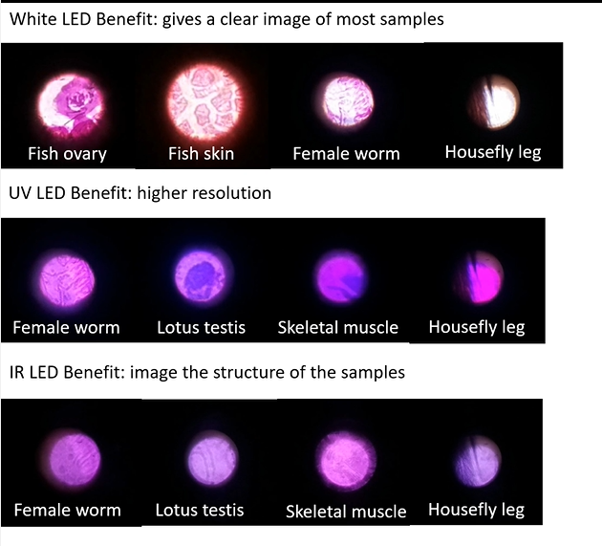
Fig. 11. Specimens under three spectra
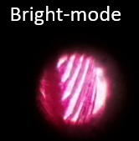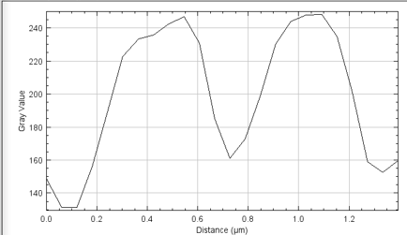
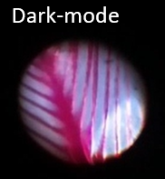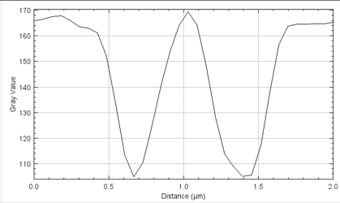
Fig. 12. bird feather under bright-mode and dark-mode

Acknowledgement
We would like to acknowledge the support and assistance of Coordinators Dr. Chung Yong Chan, Dr. Aravinda Kar, Dr. Lei Wei. We would also like to acknowledge our esteemed reviewers Dr. Kyu Young Han, Dr. Qun Zhou Sun and Dr. Xun Gong

References
[1] Bush, A., Bryant, A., Gill, C., & Pierson, H. (2019). (rep.). Portable Multi-Spectra Microscope. University of Central Florida. Retrieved February 10, 2023, from Portable Microscope - Group 27 (ucf.edu).

